|  |  |
| --- | --- |
| **To:** | Roya Solhmirzaei |
| **From:** | Team 4 - Caleb Howell, Essam Aljahmi, Yue Wang, and Kelsee Horrom |
| **Subject:** | Project 1 Checkpoint 1 |
| **Date:** | May 24, 2017 |

**Introduction:** The goal was to build a robot from the EV3 Lego Kit that could follow a black line using a light sensor. The robot should later be capable of carrying a ball and continue to follow the line with the ball elevated. After programming the robot to follow the black line, calculations were made on how fast, reliable, and how long it took for the robot to accomplish the intended task on a given track.

**Results:** The average speed of the robot was tested and timed multiple times over a straight line measured at 32 inches. After the multiple trials, the average speed of the robot was calculated to be 2.53 inches per second by taking the 32 inch distance and dividing it by each trial and then taking the average.

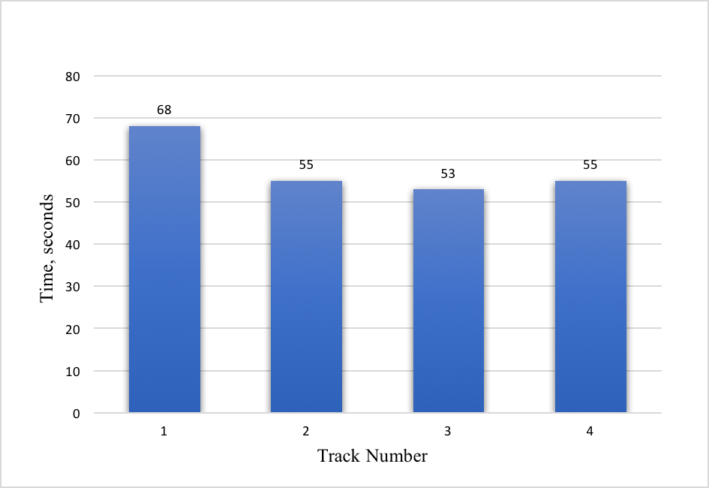    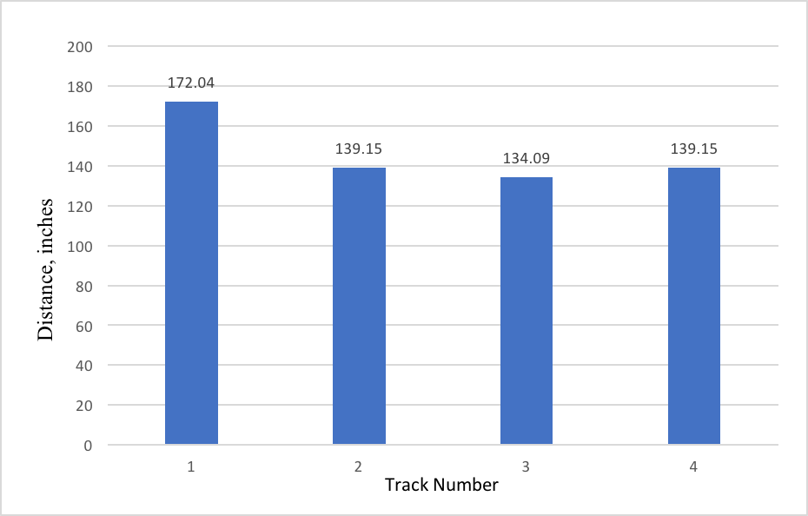

Figure 1: Robot Time in Four Tracks           Figure 2: Robot Distance in Four Tracks

**Discussion:** A problem the team had to figure out when testing the robot on the tracks was how to increase the speed of the robot while still accurately following the black line. The team as a group came together to discuss each part of the program and what it did to the robot while on the tracks.

At first the robot was swerving too fast across the black line and would go in circles. In the Simulink program the Gain was lowered to 0.6 and it seemed to solve the issue of the robot not catching the black line at the beginning of the track. The next problem the team faced was programming the robot to make it around the curves in all the tracks. The right wheelwas too fast for the program therefore the robot zoomed off the black line and went in circles again. In the Simulink program there had to be an adjustment to Constant Two. It took multiple test runs on different tracks to figure out a good Gain and Constant Two in the Simulink program.

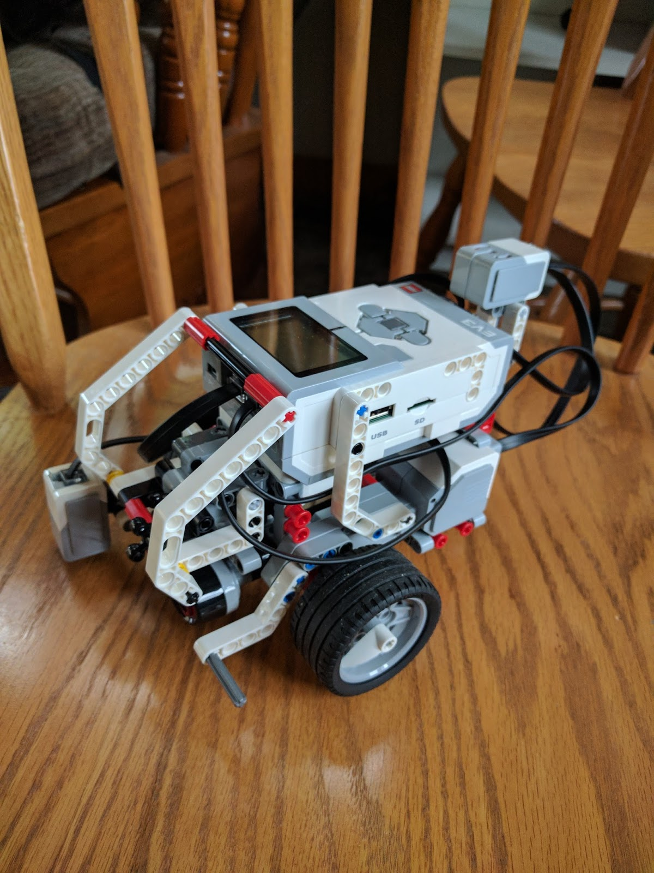

The team had no problems constructing the robot. A limitation of the EV3 Lego Kit would be not having a charger for the battery pack included in the kit. At first the team thought there might have been a problem with the sensor being on the right side of the robot because of the jerky movements. An adjustment the team thought of was to place the sensor in the middle of the robot. After adjusting the Simulink parameters the robot design was deemed effective with the sensor on the right.

When the robot followed all the tracks, the next goal was to figure out how to make the robot go faster while remaining accurate. The reason why there are different times for the four tracks is that the light sensitivity of the robot sometimes could not distinguish the black line and the white space accurately and quickly. Also each track had different types of turns for example in Figure 1 Track One, the robot took the longest time in seconds because the track was the curviest out of the rest. In Figure 2 it is shown the distance in inches the robot ran by multiplying average speed of 2.53 inches per second by the time in seconds in Figure 1.

Team goals include having the robot follow the black line accurately and quickly by programing and readjusting the Simulink parameters. Finally build a lifting mechanism for a ball that the robot can pick up while following the black line. Also figure out how to charge the robot in the future without purchasing more batteries.

The light sensor had an output of 19 when on the black line while having 100 on the white part. The First Constant Block subtracted the set point 59.5 from 19 and output -40.5. The steering-Gain block multiplied -40.5 by 0.6 and output -24.3. The signal then splits and the left motor sum block subtracts -24.3 from the base speed of 20 which is the Second Constant Block and outputs 44.3 to the motor. The right motor block adds -40.5 to 59.5 and outputs 19.2. The motors will now turn at speeds of 44.3 and 19.2, resulting in the robot turning right [1].

**References:**

1. Solhmirzaei, Roya. “2017 Summer Semester Lab 1B.” Intro to Engineering Design 100, EGR 100, 19 May 2017, Engineering Building Room 1312, East Lansing, MI. Lab Lecture PowerPoint.